FORNAX™ ePlanCheck Rule
Rule Information
Rule ID | SSW 3.1.3.8
Rule Name | Wash Area
Chapter | Part 3 Sanitary Works
Section | 3.1 Sanitary Drainage System
Handbook | Code of Practice on Sewerage and Sanitary Works  Addendum No. 2 – Nov 2004

Rule Description
3.1.3.8 Wash Area ⁽³⁻⁸⁾

The wash area shall be constructed under a roof and appropriately kerbed and designed so that no rainwater can enter the sewer. It shall be provided with either a floor waste connecting to floor trap or a floor trap connecting directly to an inspection chamber. The details are shown in Drawing No 3-8.

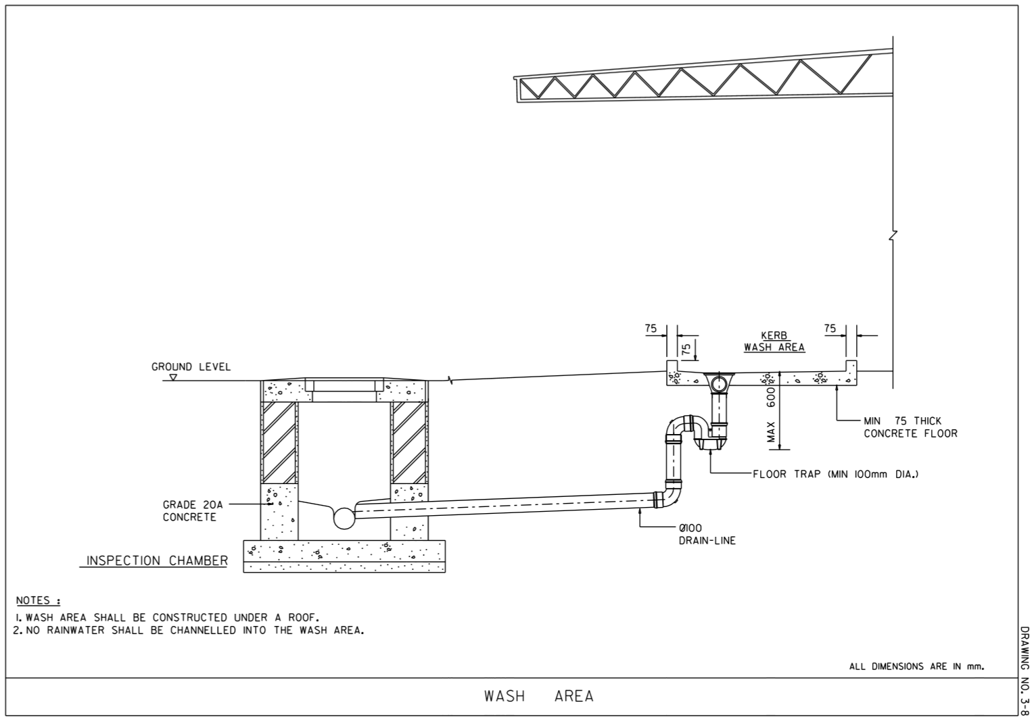

Rule Interpretation
- This rule checks for the provision of roof, kerb and floor trap requirements of the wash area.
- Rainwater is not allowed to discharge into the wash area.
- The wash area shall be fully covered with either a roof or slab. See Figure 01.
- The edges of the wash area should be enclosed with a kerb. See Figure 01.
- The minimum width of the kerb is 75 mm. Its minimum height is also 75 mm. See Figure 02.
- There should be a floor waste from the wash area that connects to a floor trap. See Figure 01.
- The floor trap should connect directly to an inspection chamber. See Figure 01.

ROOF

WASH AREA

KERB
KERB
FLOOR WASTE

INSPECTION
CHAMBER

FLOOR TRAP

SECTION
FIGURE 01

KERB
75 mm
75 mm

SECTION
FIGURE 02

Rule Scenario

Scenario 01 - Compliant
Requirement | Fully covered Wash Area, provided with 75 x 75 mm kerb, floor waste, floor trap and inspection chamber
Conditions | N.A.
Description | The Wash Area is fully covered by a roof, and is provided with a 75 x 75 mm kerb, floor waste, floor trap and inspection chamber.
ROOF

WASH AREA
KERB
75mm x 75 mm
KERB
75mm x 75 mm

FLOOR WASTE

INSPECTION
CHAMBER

FLOOR TRAP

SECTION
FIGURE SCENARIO

Scenario 01 - Non-Compliant 1
Requirement | Fully covered Wash Area
Conditions | N.A.
Description | The Wash Area is uncovered.
NO ROOF
WASH AREA
KERB
KERB
FLOOR TRAP
INSPECTION
CHAMBER
FLOOR WASTE

SECTION
FIGURE SCENARIO

Scenario 01 - Non-Compliant 2
Requirement | Fully covered Wash Area
Conditions | N.A.
Description | The Wash Area is partially covered by a roof.
ROOF

WASH AREA
KERB
KERB

FLOOR WASTE

INSPECTION
CHAMBER

FLOOR TRAP

SECTION
FIGURE SCENARIO

Scenario 02 - Non-Compliant 1
Requirement | Wash Area enclosed by 75mm wide x 75mm high kerb
Conditions | N.A.
Description | The kerb width is only 65 mm.
ROOF

WASH AREA

KERB
65mm x 75 mm
KERB
65mm x 75 mm

FLOOR WASTE

INSPECTION
CHAMBER

FLOOR TRAP

SECTION
FIGURE SCENARIO

Scenario 02 - Non-Compliant 2
Requirement | Wash Area enclosed by 75mm wide x 75mm high kerb
Conditions | N.A.
Description | The kerb height is only 65 mm.
ROOF

WASH AREA

KERB
75mm x 65 mm
KERB
75mm x 65 mm

FLOOR WASTE

INSPECTION
CHAMBER

FLOOR TRAP

SECTION
FIGURE SCENARIO

Scenario 02 - Non-Compliant 3
Requirement | Wash Area enclosed by 75mm wide x 75mm high kerb
Conditions | N.A.
Description | There is no kerb provided for the Wash Area.
ROOF

WASH AREA

NO KERB
NO KERB

FLOOR WASTE

INSPECTION
CHAMBER

FLOOR TRAP

SECTION
FIGURE SCENARIO

Scenario 03 - Non-Compliant 1
Requirement | Wash Area connects to Floor Waste, Floor Trap and Inspection Chamber
Conditions | N/A
Description | The Wash Area has no Floor Waste. There is a Floor Trap connecting to an Inspection Chamber.
ROOF

WASH AREA

KERB
KERB
NO FLOOR WASTE

INSPECTION
CHAMBER

FLOOR TRAP

SECTION
FIGURE SCENARIO

Scenario 03 - Non-Compliant 2
Requirement | Wash Area connects to Floor Waste, Floor Trap and Inspection Chamber
Conditions | N/A
Description | The Floor Waste does not connect to a Floor Trap.
ROOF

WASH AREA

KERB
KERB

FLOOR WASTE

INSPECTION
CHAMBER

NO FLOOR TRAP

SECTION
FIGURE SCENARIO

Scenario 03 - Non-Compliant 3
Requirement | Wash Area connects to Floor Waste, Floor Trap and Inspection Chamber
Conditions | N/A
Description | The Wash Area has a Floor Waste connecting to a Floor Trap, but there is no Inspection Chamber.
ROOF

WASH AREA

KERB
KERB

FLOOR WASTE

FLOOR TRAP
NO
INSPECTION
CHAMBER

SECTION
FIGURE SCENARIO

Scenario 03 - Non-Compliant 4
Requirement | Wash Area connects to Floor Waste, Floor Trap and Inspection Chamber
Conditions | N/A
Description | The Wash Area has a Floor Waste connecting to a Floor Trap, but it is not connected to the Inspection Chamber.
ROOF

WASH AREA

KERB
KERB

FLOOR WASTE

INSPECTION
CHAMBER

FLOOR TRAP
NOT CONNECTED

SECTION
FIGURE SCENARIO

Model PreCheck

Required Elements | Required Attributes
Space | LongName contains “Wash Area”
BuildingElementProxy | Name contains “Kerb”
WasteTerminal | Family Name contains “Floor Waste”
PipeFitting | Family Name contains “Floor Trap”
DistributionChamberElement | Name contains “Inspection Chamber”
Roof | Any
Slab | Any

Rule Parameters

System Type
Cold Water
Hot Water
 | Sanitary | 
 | Sewerage
Vent

Space Type 1
State | Property | Operator | Value
Include | LongName | Contains | Wash Area
Exclude | Any | Match | N.A.
 |  | N.A. | <User defined>

Element Type 1
State | Type | Property | Operator | Value
Include | BuildingElementProxy | Name | Contains | Kerb
Exclude |  | Any | Match | N.A.
 |  |  | N.A. | <User defined>

Element Type 2
State | Type | Property | Operator | Value
Include | WasteTerminal | Name | Contains | Floor Waste
Exclude |  | Any | Match | N.A.
 |  |  | N.A. | <User defined>

Element Type 3
State | Type | Property | Operator | Value
Include | Roof | Any | N.A. | N.A.
Include | Slab | Any | N.A. | N.A.
Exclude |  | Name | Match | <User defined>
 |  |  | Contains

Element Type 4
State | Type | Property | Operator | Value
Include | Pipefitting | Name | Contains | Floor Trap
Exclude |  | Any | Match | N.A.
 |  |  | N.A. | <User defined>

Element Type 5
State | Type | Property | Operator | Value
Include | DistributionChamberElement | Name | Contains | Inspection Chamber
Exclude |  | Any | Match | N.A.
 |  |  | N.A. | <User defined>

Space Type 1 Condition
Kerb Minimum Width | 75 | mm
Kerb Minimum Height | 75 | mm
Note:
The Wash Area including the Kerb must be fully covered by roof or slab.
The Wash Area must have a Floor Waste.
The Floor Waste must connect to a Floor Trap.
The Floor Trap must connect to an Inspection Chamber.

Result Messages
- 3.1.3.8 Wash Area
  - Non-compliant (TotalResultNumeric)
    - BuildingStorey (TotalResultPerFloorNumeric)
      - No cover; SpaceType1 Name
      - Partially covered; SpaceType1 Name
      - Kerb width is less than 75 mm; KerbWidth mm; ElementType1 Name
      - Kerb height is less than 75 mm; KerbHeight mm; ElementType1 Name
      - No Kerb found
      - No Floor Trap found
      - No Inspection Chamber found
      - No Connection; ElementType4 Name; ElementType5 Name
  - Compliant (TotalResultNumeric)
    - BuildingStorey (TotalResultPerFloorNumeric)
      - The Wash Area is fully covered and appropriately kerbed. It is connected to a floor waste, floor trap and inspection chamber.
      - SpaceType1 Name
      - ElementType1 Name
      - ElementType2 Name
      - ElementType4 Name
      - ElementType5 Name
  - Attention (TotalResultNumeric)
    - BuildingStorey (TotalResultPerFloorNumeric)
    - “No Wash Area found.”

Sample Result Messages
- 3.1.3.8 Wash Area
  - Non-compliant (8)
    - 1st Storey (8)
      - No cover; Wash Area 01
      - Partially covered; Wash Area 01
      - Kerb width is less than 75 mm; Kerb Width 65mm; Concrete Floor Generic 150mm THK
      - Kerb width is less than 75 mm; Kerb Height 65mm; Concrete Floor Generic 150mm THK
      - No Kerb found
      - No Floor Trap found
      - No Inspection Chamber found
      - No Connection; Independent Brass Trap 100mm; Inspection Chamber 01
  - Compliant (6)
    - 1st Storey (5)
      - The Wash Area is fully covered and appropriately kerbed. It is connected to a floor waste, floor trap and inspection chamber.
      - Wash Area 01
      - Kerb Generic 75mm
      - Floor Drain 100mm
      - Independent Brass Trap 100mm
      - Inspection Chamber 01
  - Attention (1)
    - 1st Storey (1)
      - No Wash Area found.

Sample Result Model Views
- 3.1.3.8 Wash Area
  - Non-Compliant
    - Sectional elevation view.
    - Highlight checked elements.
    - Kerb Width of the element is displayed.
    - All other elements are translucent except for the checked elements.
  - Compliant
    - Sectional elevation view.
    - Highlight checked elements.
    - Kerb Width of the element is displayed.
    - All other elements are translucent except for the checked elements.

Testing Scenario Notes
- Scenario 01 - Compliant
- Level 01
- Wash Area is fully covered by a roof.

- Scenario 01 – Non-Compliant 1
- Level 01
- Wash Area is uncovered.

- Scenario 01 – Non-Compliant 2
- Level 01
- Wash Area is partially covered by a roof.

- Scenario 02 – Non-Compliant 1
- Level 01
- Wash Area slab edges are fully kerbed all around. Kerb width is only 65mm.

- Scenario 02 – Non-Compliant 2
- Level 01
- Wash Area slab edges are fully kerbed all around. Kerb height is only 65mm.

- Scenario 02 – Non-Compliant 3
- Level 01
- No kerb provided for the Wash Area slab.

- Scenario 03 – Non-Compliant 1
- Level 01
- The Wash Area has no Floor Waste but there is no Floor Trap and Inspection Chamber.

- Scenario 03 – Non-Compliant 2
- Level 01
- The Wash Area has a Floor Waste but there is no Floor Trap connecting to an Inspection Chamber.

- Scenario 03 – Non-Compliant 3
- Level 01
- The Wash Area has a Floor Waste. There is a Floor Trap, but there is no Inspection Chamber in the model.

- Scenario 03 – Non-Compliant 4
- Level 01
- The Wash Area has a Floor Waste. There is a Floor Trap, but there is no connection to the Inspection Chamber.

- Attention Scenario 01
- Level 01
- There is no Wash Area in the model.

Model:
SSW 3.1.3.8 Scenario 01 – Compliant_v2.ifc
SSW 3.1.3.8 Scenario 01 – Non-Compliant 1_v2.ifc
SSW 3.1.3.8 Scenario 01 – Non-Compliant 2_v2.ifc
SSW 3.1.3.8 Scenario 02 – Non-Compliant 1_v2.ifc
SSW 3.1.3.8 Scenario 02 – Non-Compliant 2_v2.ifc
SSW 3.1.3.8 Scenario 02 – Non-Compliant 3_v2.ifc
SSW 3.1.3.8 Scenario 03 – Non-Compliant 1_v2.ifc
SSW 3.1.3.8 Scenario 03 – Non-Compliant 2_v2.ifc
SSW 3.1.3.8 Scenario 03 – Non-Compliant 3_v2.ifc
SSW 3.1.3.8 Scenario 03 – Non-Compliant 4_v2.ifc
SSW 3.1.3.8 Attention Scenario 01_v2.ifc

Modelling Guideline
- Specify Room Name to contain “Wash Area” for relevant Space.
- Specify Type Name to contain “Kerb” for relevant Slab Edge.
- Specify Family Name to contain Floor Waste” for relevant plumbing fixture.
- Specify Family Name to contain “Floor Trap” for relevant plumbing fixture.
- Specify Family Name to contain “Inspection Chamber” for relevant plumbing fixture.

Specification Log
RA | Delfin M. Ballo, Jr.
ePC version
Updates | - V2-Update rule interpretation and scenarios based on latest PUB comments

